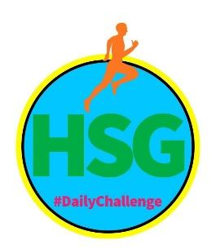
HAMPSHIRE SCHOOL GAMES
#DAILYCHALLENGE - SCHOOL GAMES MARK MAY: 18TH – 22ND MAY

Name: Year Group: School:

Warm Up Game – Fortune Teller

Make sure you fold your piece of paper into a square and cut off the excess paper.
Fold your paper in half lengthways. Crease the edge of the fold, and then unfold the paper back into the square shape.
Fold the paper again but this time, fold it in the opposite direction. Then crease the edge and unfold back into the square. You should now have a large X going through the centre.
Fold all of the corners towards the centre. You should be left with a diamond shape.
Flip the paper over so the folded corners are facing downwards. Then fold all of the corners inwards again. You should be left with a smaller square.
Fold the paper in half again in each direction.
Flip the paper over and there should be four small squares. Pull these outwards, and the centre should fold inwards. Insert your fingers into the spaces.
Copy the exercises above and recreate fortune teller.

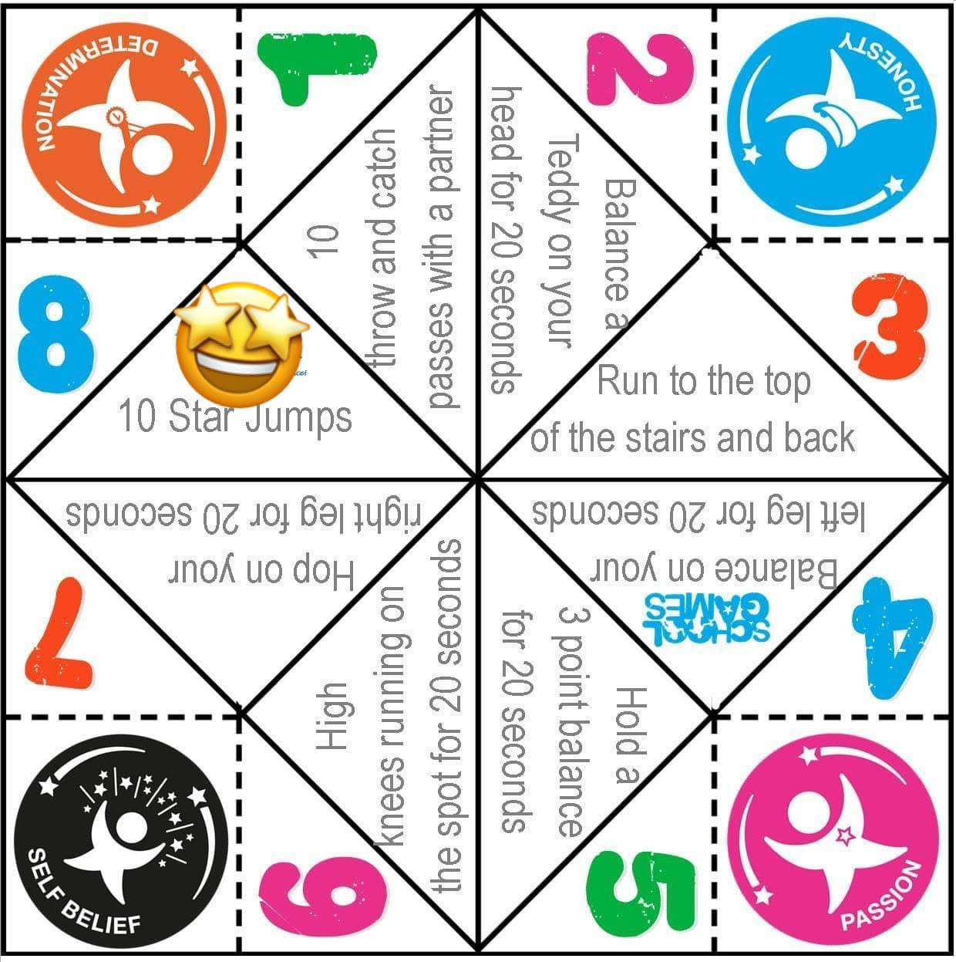

This week’s challenges all focus on the School Games Values of Determination, Passion,
Honesty and Self Belief

 |  | MONDAY | TUESDAY | WEDNESDAY | THURSDAY | FRIDAY
MOVE IT MONDAY  KS1 – SWIMMING  FLUTTER KICK | - Lay on your tummy, making the shape of a rocket (arms above your head, legs together)  - Can you lift your legs off the floor?  - Now try to kick them, small fast movements, just like you are doing a front crawl (flutter) kick. How long can you do it for?
KS2 – SWIMMING  SWIM IT | - Lay on your tummy, making the shape of a rocket (arms above your head, legs together)  - Can you lift your arms and legs off the floor?  - Now kick your legs and move your arms, small fast movements - up and down. How long can you do it for?
TRY IT TUESDAY  KS1 – SWIMMING  JUMP TO THE MOON | - Standing with your feet hip width apart  - Arms above your head (like a rocket)  - Bend your knees slightly and jump as high as you can! TRY TO TOUCH THE SKY!  - How many times can you do that in 30 seconds?
KS2 – SWIMMING  SQUAT JUMP | - Standing with your feet hip width apart  - Arms above your head (like a rocket)  - Bend your knees in a squat position, keeping your back straight and weight on your heels  - Explode up, jumping as high as you can! TRY TO TOUCH THE SKY!  - How many times can you do that in 30 seconds?
WORK IT WEDNESDAY  MULTI SKILLS  SPEED BOUNCE WITH A PASS | - Find something to jump over and place it on the ground. Jump sideways and land using two feet  - After two jumps, you must pass an object (soft toy/ball) around your body two times. Then repeat - 2 x jump /2 ball pass.  - How many jumps can you do? KS1 - 30seconds, KS2 - 45 seconds
TRAIN IT THURSDAY  MULTI SKILLS  AGILITY RUN WITH THROW | - Place 4 markers on the ground. KS1-1.5M, KS2-2m apart. Have 5 soft objects at the first marker.  - Pick up one object, run in and out of the markers. At the fourth marker, turn and face all markers. Throw an object under arm and aim for one of the markers. 5 points for closest marker, 10 points second, 20 points for marker furthest away. Run back through markers and repeat
FRIDAY FINISHER | REPEAT ALL ACTIVITIES AND TRY AND BEAT YOUR SCORE! GOOD LUCK!!
If possible the challenges should be done between 9am and 3pm – send in your results to earn a point for your school. You can take a picture and send to us the Hampshire SGOs via Jenniferlknight9@gmail.com or amy.rodger@solent.ac.uk or you can get in contact with the Hampshire SGO Twitter and Facebook page @HampshireSGO.

