Year 4 Homework, Autumn Term 1 Week 8 - Support

|  |  |  |
| --- | --- | --- |
| **Maths** |  | |
|  | |

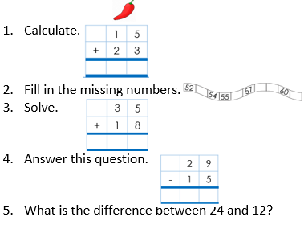

Solve the number sentences in your homework book:

43 + 17 =

67 – 15 =

5 x 4 =

36 ÷ 3 =

**Reading:**

Remember you must read every day for 15 minutes. This can be reading a book or practising your phonic or digraphs. Please record this in your Home link book.

**Spellings**

saw

lawn

shawl

brawn

fawn

prawn

draw

many

other

**English Challenge**



**Times Tables Activities**

**Please do some of the following:**

Daily times tables on TT Rockstars

Daily time tables in booklet

Daily chanting

Please remember: All homework is marked in class with the children and will not have written feedback on it.

Homework is due in on the following Friday