HAMPSHIRE SCHOOL GAMES
PRIMARY PERSONAL BEST CHALLENGES
WEEK TWO 30 MARCH – 03 APRIL

Name: Year Group: School

To prepare you for your daily physical challenge you need to first warm up!

This week we are suggesting playing the Monopoly Fitness Game.

You can play this with your family!

Choose a piece of equipment to represent your character!

Take turns in rolling the dice and move your piece the correct number of squares

Make sure you complete the activity on the square before the next person can take their turn

Keep playing for 20 minutes

You should be nice and warm now to take part in your Daily Challenge

Have a go and make sure you let your teacher have your score or email your SGO with your name, age, school and score!

Good Luck and have Fun!
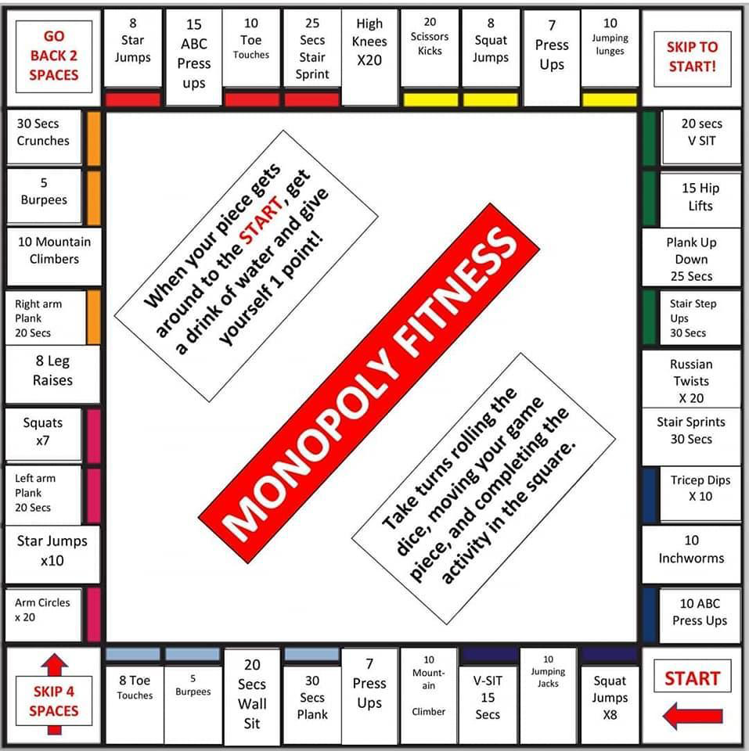

ACTIVITY | DESCRIPTION  EACH ACTIVITY TO LAST 5 MINUTES | MONDAY | TUESDAY | WEDNESDAY | THURSDAY | FRIDAY
MOVE IT MONDAY  MATCHING PAIRS  Playing cards  2 markers | Moving between 2 spots, distance is up to you and how much space you have! Lay 5 pairs of playing cards at one end and start at the other end. Move towards the cards, turn over two cards at a time trying to match pairs.  How can you move - skip, hop, side step, jog, walk. Why not turn this into a maths challenge as well by subtracting or adding numbers together
TRY IT TUESDAY  SOCK MOVE  10 pairs of socks | Sitting on the floor, how many items can you move using only your feet from one pile to another in 30 seconds.  Both hands on the floor  1 hand on floor  No hands on the floor
WORK OUT WEDNESDAY  TARGET  10 pairs of socks  3 items of clothing | Place 3 items of clothing, each slightly further away. Closest 2 points, middle 5 points, furthest 10 points.  - Throw one pair of socks at a time, under arm  - How many points can you score in 30 seconds  Try with your left hand and right hand, which is better?
TRAIN IT THURSDAY  BALANCE CHALLENGE  4 pairs of socks | Balance on 1 foot and see how quickly you can pick up 4 pairs of socks in front of you.  - hold your balance and try not to put your foot down  Try on your left foot and right foot, which is better
FRIDAYS  FINISHER | Repeat all the activities and try to beat your score!

Challenges should be done between 9am and 3pm – send through your results daily to earn a point for your school.
You can take a picture and send it to your School Games Organiser (SGO) for your area, more details can be found on the next page.
You can also follow the Hampshire SGOs and Hampshire SGO Facebook page where we will be updating the results each day

Hampshire School Games Organisers (SGOs) Contact Details

Basingstoke – Phil Jeffs pjeffs@brightonhill.hants.sch.uk Twitter@BasingstokeSGO

East Hants (Perins) – Sara Galliers galliers@perins.hants.sch.uk

Fareham – Sam Latter schoolgamesorganiser@henrycort.org Twitter @SGOFareham

Gosport – Jaz Huntington jhuntington@bayhouse.gfmat.org Twitter @SGOgosport

Havant & Waterlooville – Jen Knight jenniferlknight9@gmail.com Twitter @AndHavant

I.O.W Andy Day/Tony Harris sgoiow@hotmail.co.uk

Test Valley (Mountbatten) – Holly Shirley holly.shirley@mountbatten.hants.sch.uk Twitter @SGOTest

New Forest – James Cross j.cross@testwood.hants.sch.uk Twitter @newforestsp

N.East Hampshire – Catherine Mckeracher c.mckeracher@samuelcody.hants.sch.uk Twitter @NeHantsSGO

N.Eastleigh & Winchester – Alison MacQuillin Alison.Macquillin@gmail.com Twitter @SGO_new

N.Eastleigh & Winchester – Emma White ewhite26@btinternet.com Twitter @SGO_new

Portsmouth – Madeleine Campbell mcampbell@priorysouthsea.org Twitter @Pompey_SSP

S.Eastleigh & Winchester – Darren Waterman Darren.waterman@yahoo.com

Southampton – Amy Rodger amy.rodger@solent.ac.uk Twitter @SouthamptonSGO

Southampton - Mark Lavelle mark.lavelle@solent.ac.uk Twitter @SouthamptonSGO

