Year 4 Recommended Reading List

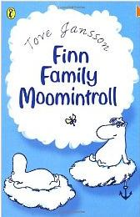
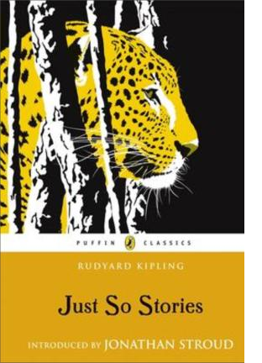
Classics
Dahl, Roald Fantastic Mr Fox; Matilda
Goodheart, Pippa Flow
Grimm, The Brothers Fairy Tales
Jannson, Tove Moomin Valley (series) Kemp, Gene The Clock Tower Ghost Kipling, Rudyard Just So Stories
Lewis, C. S. Chronicles of Narnia
Martin, J. P. Uncle Stories
Norton, Mary Bed-knob and Broomstick
White E B Charlotte’s Web

Great fiction
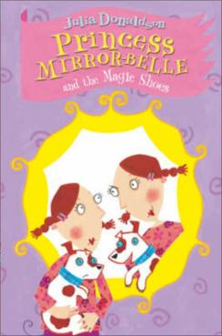
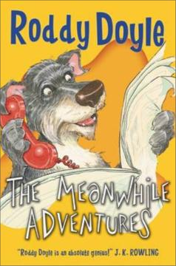
Apps, Roy Melvin the Avenger Aunt Boomerang (series) Ashton, Charles The Boy who was a Bear
Blyton, Enid The Secret Seven Blackman, Malorie Snow Dog Cooper, Susan The Boggart
Cowell, Cressida How to Train Your Dragon Cross, Gillian The Great Elephant Chase Deary, Terry Knights Tale
Donaldson, Julia Princess Mirror-Belle (series) Doyle, Roddy Meanwhile Adventures
Fine, Anne The Country Pancake, Bill’s New Frock
French, Vivian The Tiara Club (series), Sharp Sheep
Gavin, Jamila Grandpa Chatterji Years, The Whistling Monster
Gantos, Jack Joey Pigza Swallowed the Key; Gardner, Sally The Invisible Boy
Gleitzman, Morris Blabbermouth
Haptie, Charlotte Otto in the Time of the Warrior
Hendry, Diana Harvey Angell
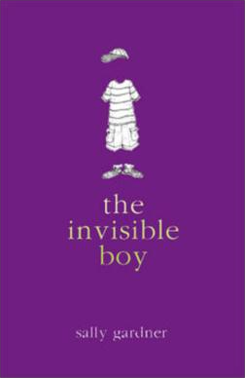
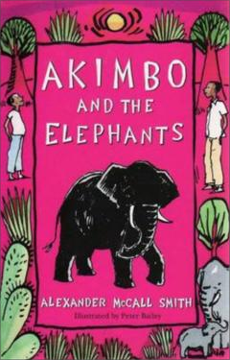
Hinton, Nigel Beaver Towers (series)
Hirsch, Odo Something Fishy, Hazel Green! Hoeye, Michael Time Stops for No Mouse Horowitz, Anthony The French Confection
Kilworth, Gary Spiggot’s Quest (series)
King-Smith, Dick The Fox Busters; The Sheep-Pig
Langley, Noel The Land of Green Ginger McCall Smith, Alexander Akimbo & the Elephants McConnell, Sarah Scarlet Silver (series)
Molloy, Michael The House on Falling Star Hill
Morpurgo, Michael The Marble Crusher
Nimmo, Jenny The Owl Tree, The Bodigulpa
Oppel, Kenneth Silverwing Saga
Palmer, Tom Football Academy (series) Pearce, Philippa The Battle of Bubble and Squeak
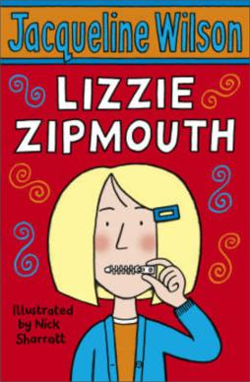
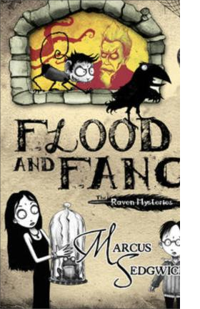
Pennac, Daniel Eye of the Wolf
Rees, Gwyneth Cosmo & the Great Witch Escape
Ridley, Philip Scribbleboy; Zip’s Appollo Riddell, Chris Ottoline Goes to School Sedgewick, Marcus Flood and Fang
Wilson, Jacqueline Lizzie Zipmouth

Great Adventures
Burnford, Sheila The Incredible Journey
Creswell, Helen A Gift from Wrinklesea
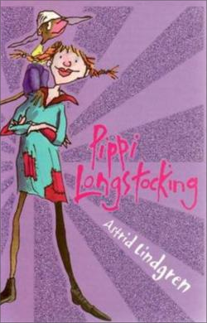
Dann, Colin Animals of Farthing Wood (series) Goodheart, Pippa Flow
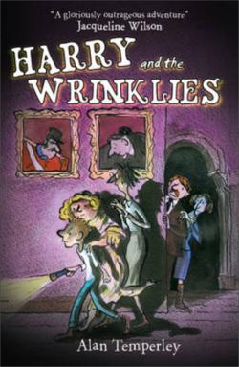
Juster, Norton The Phantom Tolbooth King, Clive Stig of the Dump Leeson, Robert The Third Class Genie Lindgren, Astrid Pippi Longstocking Pullman, Philip Count Karlstein Proysen, Alf Mrs Pepperpot

Humour
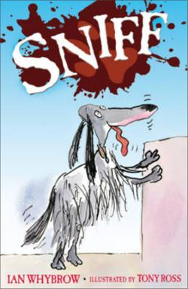
Anderson, Sorel The Clumsies Andrae, Giles Billy Bonkers Ardagh, Philip Grubtown Tales Colfer, Eoin Spud Murphy
Davies, Katie Great Hamster Massacre
Jennings, Paul Undone, Unbelievable
McKay, Hilary Charlie & the Big Birthday Bash
Scieska, Jon The Three Little Pigs
Small, Charlie The Adventures of Charlie Small (series) Strong, Jeremy The Hundred Mile an Hour Dog Temperley, Alan Harry & the Wrinklies
Umansky, Kay Pongwiffy (series) Whybrow, Ian Sniff (series)

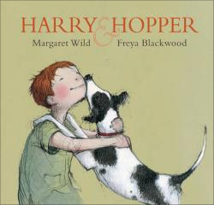
Picture Books
Duffy, Carol Ann The Tear Thief Foreman, Michael The Little Reindeer Gaiman, Neil The Wolves in the Walls Hughes, Shirley The Lion & the Unicorn Wild, Margaret Harry & Hopper
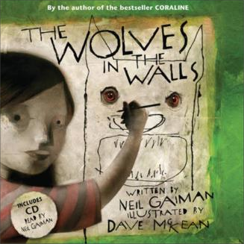
Williams, Marcia Bravo, William Shakespeare!

Useful websites: www.lovereading4kids.co.uk www.achuka.co.uk www.booktrustchildrensbooks.org.uk

Books in italics are ideal for sharing.

