Year 6 Recommended Reading List

Classics:
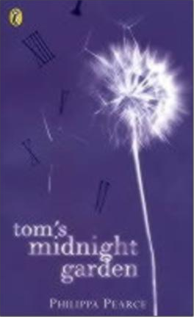
Barrie, J. M. Peter Pan
Burnett, F Hodgson The Secret Garden
Carroll, Lewis Alice’s Adventures in Wonderland
Dann, Colin Animals of Farthing Wood
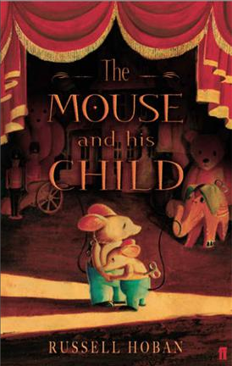
Gallico, Paul The Snow Goose Hoban, Russell The Mouse & his Child Kipling, Rudyard Jungle Stories
Lewis, C. S. Chronicles of Narnia
Lofting, Hugh Doctor Dolittle Stories
London, Jack The Call of the Wild; White Fang
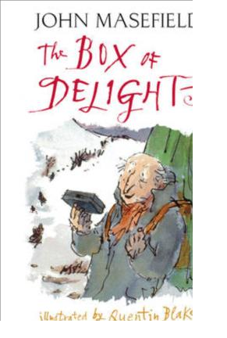
Masefield, John Box of Delights
E. Nesbit Five Children & It
Pearce, Philippa Tom’s Midnight Garden Sewell, Anna Black Beauty Streatfield, Noel Ballet Shoes

Great Stories:
Aiken, Joan Wolves of Willoughby Chase (series) Almond, David Skellig; The Fire Eaters
Blackman, Malorie Dangerous Reality; Forbidden Game
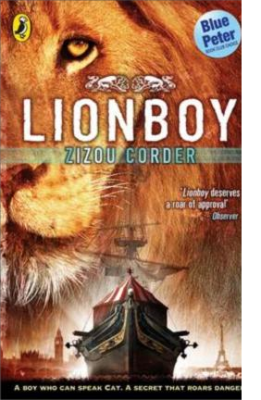
Colfer, Eoin Artemis Fowl (series) Corder, Zizou Lionboy (series)
Doherty, Berlie Daughter of the Sea; The Sailing Ship Tree
Fine, Anne Charm School; Madame Doubtfire
Funke, Cornelia Inkheart
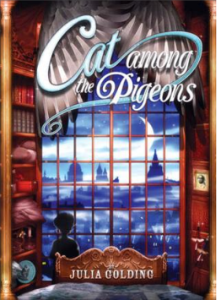
Gaiman, Neil Coraline, The Graveyard Book Garner, Alan The Weirdstone of Brisingamen Gibbons, Alan The Shadow of the Minotaur Golding, Julia Cat Royal (series)
Higson, Charlie Young Bond (series) Horowitz, Anthony Alex Rider (series)
Ibbotson, Eva The Secret Platform 13; Monster Mission
Jones, Terry The Saga of Eric the Viking
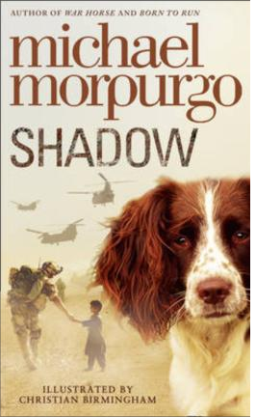
Kemp, Gene The Turbulent Term of Tyke Tyler Lively, Penelope The Ghost of Thomas Kempe McCaughrean, Geraldine Peter Pan in Scarlett; The Odyssey Morpurgo, Michael Shadow
Naughton, Bill The Goalkeeper’s Revenge & Other Stories
O’ Brien, Robert Mrs Frisby & the Rats of Nimh
Nimmo, Jenny Children of the Red King
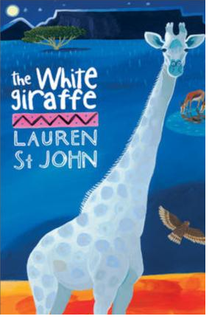
Paver, Michelle Chronicles of Ancient Darkness (series) Pennac, Daniel Dog; The Eye of the Wolf
Pullman, Philip The Tiger in the Well (series)
Reed, Anthony Baker Street Boys (series)
Riodan, Rick Percy Jackson (series)
Sachar, Louis Holes
Said, S. F. Varjac Paw
St. John, Lauren The White Giraffe Stewart and Riddle Edge Chronicles Wilson, Jacqueline The Lottie Project
Historical:
Bawden, Nina Carrie’s War; The Peppermint Pig
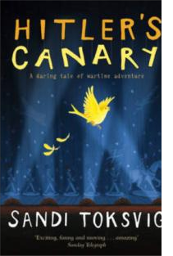
Breslin, Theresa Across the Roman Wall; Whispers in the
Graveyard
Buckley-Archer, Linda Gideon the Cutpurse
Cavendish, Grace Lady Grace Mysteries: A is for Assassin
Cooper, Susan King of Shadows (about Shakespeare); The
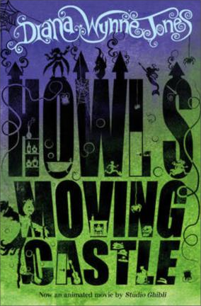
Dark is Rising (series) Doherty, Berlie Street Child
Farmer, Penelope Charlotte Sometimes
Magorian, Michelle Goodnight Mr. Tom
Newberry, Linda Blitz Boys; Flightsend; Ice Cat Paton Walsh, Jill The Dolphin Crossing Serraillier, Ian The Silver Sword
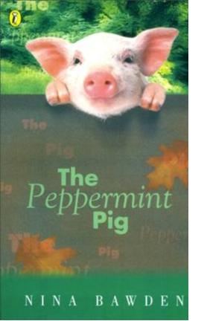
Toksvig, Sandy Hitler’s Canary
Various My Story (series)
Westall, Robert The Kingdom by the Sea
Wynne-Jones, Diana Howl’s Moving Castle

Funny:
Gleitzman, Morris Worry Warts
Landy, Derek Skulduggery Pleasant (series)
Pratchett, Terry The Amazing Maurice & his Educated Rodents
Temperley, Alan Harry and the Wrinklies; Harry and the
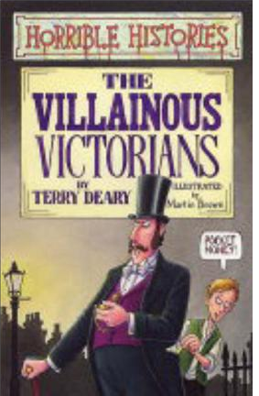
Treasure of Eddie Carver
Walliams, David The Boy in the Dress and other titles

Sport:
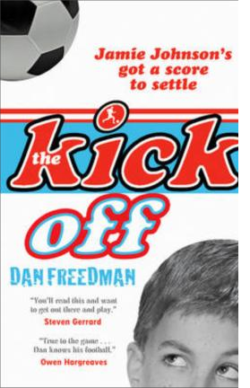
Freedman, Dan Jamie Johnson (series)
Palmer, Tom Foul Play (Football detective series)

Non-Fiction:
Deary, Terry Horrible Histories (series)
Farman, John The Very Bloody History of Britain
Grogan, John Marley & Me
Williams, Marcia Mr William Shakespeare’s Plays

Useful websites

www.lovereading4kids.co.uk www.achuka.co.uk www.booktrustchildrensbooks.org.uk

