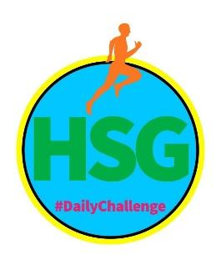

HAMPSHIRE SCHOOL GAMES
SCHOOL GAMES MARK MAY – WEEK SIX: 4th – 8th May

This week the challenges have been split into KS1 and KS2 challenges – please see the appropriate sheet below

Name: Year Group: School:

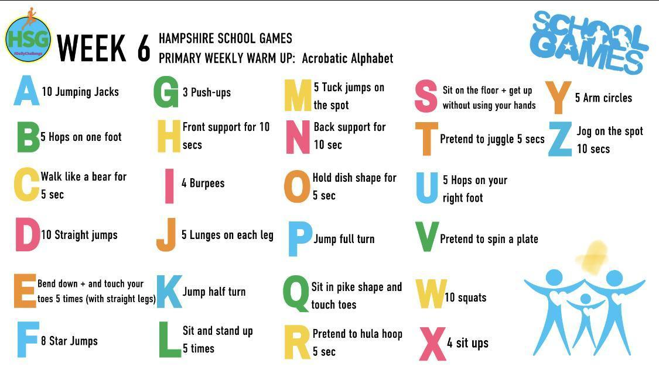
Weekly Warm Up: ACROBATIC ALPHABET
To prepare you for your daily physical challenge you need to first warm up!
Work your way through the Alphabet doing the movement that goes with each letter.
What words will you spell out? Why not try your full name on Monday, your favourite sport on Tuesday, your favourite lesson on Wednesday, your favourite movie on Thursday. Be creative!

Equipment needed for your daily challenges:
A ball – you can make a ball out of clothing if you do not have one. Place 2 t-shirts on top of a jumper and then use the arms of the jumper to wrap up the t-shirts to make a ball shape.

A basket – You can use a laundry basket or a toy box

Markers – any flat household item will work.

This week’s challenges all focus on the School Games Values of Determination, Passion, Honesty and Self Belief

KEY STAGE 1 STUDENT CHALLENGES

ACTIVITY | DESCRIPTION | MONDAY | TUESDAY | WEDNESDAY | THURSDAY | FRIDAY
MOVE IT MONDAY  FOOTBALL DRIBBLING  Ball & 2 markers* | KS1 Using a ball of your choice and 2 markers placed 5 metres apart  You will have 2 minutes to dribble the ball as much as you can.  Every time you dribble the ball to the end and back, you get 1 point. How many points can you score?  *See the warm up page for equipment ideas if you do not have a ball.
TRY IT TUESDAY  FOOTBALL SHOOTING  6 objects & a ball* | KS1- Find 6 objects of different sizes – empty water bottles, milk bottles, tins etc, and a ball of your choice.  Place the objects 3 metres away from where you are shooting from and space them apart. Using a ball of your choice, try and knock down all 6 objects.  You will have 10 attempts to record your best score (1 point for each object knocked down).
WORK OUT WEDNESDAY  BASKETBALL  SHOOTING  Ball and a Basket* | KS1 Stand in front of your basket and drop the ball in. If the ball goes through you will have scored one basket. Take one step back and shoot the ball. If it goes through you will have scored 2 baskets in a row. Then take a further step back and shoot again. If it goes through you will have scored 3 baskets. If you miss then your score will be 2 baskets and you must start again.  How many baskets can you get in a row? You can have a maximum of 6 goes
TRAIN IT THURSDAY  NETBALL  PASSING AND RECEIVING | KS1 You will need a partner or a wall about 10 steps apart. Keep passing the ball, trying not to drop It.  If a player drops the ball, they must kneel on one leg and then continue throwing and catching from that position. If the same player drops the ball again, they must kneel down on both knees but if they catch the ball they can stand back up. 1st dropped ball - one knee, 2nd dropped ball - two knees, 3rd dropped ball - one elbow, 4th dropped ball - two elbows.  If you successfully catch the ball then you get the use of that body part back.  Play for 5 minutes- How many times did you drop the ball?
FRIDAY FINISHER | Repeat all the activities and try to beat your scores
Challenges should be done between 9am and 3pm – send through your results to us in order to earn a point for your school. You can take a picture and send it to Jenny or Amy via email JenniferLKnight9@gmail.com or amy.rodger@solent.ac.uk, or via Facebook Messenger/Twitter @HampshireSGO.
KEY STAGE 2 STUDENT CHALLENGES

ACTIVITY | DESCRIPTION | MONDAY | TUESDAY | WEDNESDAY | THURSDAY | FRIDAY
MOVE IT MONDAY  FOOTBALL DRIBBLING  Ball & 4 markers* | Place your 4 markers on the ground approximately 1 metre apart.  Using your foot dribble the ball in and out of the markers and back to the start; every time you do this you will score a point!  You will have 2 minutes to complete as many as possible  How many can you do?  Have a few goes and record your best score  *See the warm up page for equipment ideas if you do not have a ball.
TRY IT TUESDAY  FOOTBALL SHOOTING  6 objects & a ball* | You will need 6 objects of different sizes – empty water bottles, milk bottles, tins etc,. Place the objects on the ground standing up, spacing them apart to become targets.  Challenge yourself by placing markers at 2 metres, 3 metres and 5 metres away from the targets.  Try and knock down as many objects as possible with your ball. You can pick objects back up once they have all been knocked down to continue scoring.  If you started at 2m you score 1 point; If you started at 3m score 3 points and if you stared at 5m score 5 points for each target you hit!  You will have 2 minutes to score as many points as possible
WORK OUT WEDNESDAY  BASKETBALL  SHOOTING  Ball and a Basket* | Stand in front of your basket. Pass the ball around your head, then around your hips and then around your knees then drop the ball into your basket. If the ball goes in you will have scored one basket.  Take a step back and pass the ball around your body in the same sequence then shoot the ball. If it goes in your will have scored 2 baskets in a row.  Then take another step back and pass the ball around your body and shoot again. If it goes in you would have scored 3 baskets. If you miss or drop the ball then your score will be 2 baskets and you must start again.  How many baskets can you get in a row without dropping the ball or missing the basket? You can have a maximum of 6 attempts.
TRAIN IT THURSDAY  NETBALL  PASSING AND RECEIVING | Working on your own you will be practising your ball handling skills. Can you pass the ball back and forth, from one hand to the other hand:  - In front of your body.  - Above your head  How many times can you do this before you drop the ball?  The final challenge is the clapping challenge-  Throw the ball up high and clap. How many times can you clap before you catch the ball?  Have a few goes and record how many times you clapped before you caught the ball.
Fridays Finisher | Repeat all the activities and try to beat your score!
Challenges should be done between 9am and 3pm – send through your results to us in order to earn a point for your school. You can take a picture and send it to Jenny or Amy via email JenniferLKnight9@gmail.com or amy.rodger@solent.ac.uk, or via Facebook Messenger/Twitter @HampshireSGO.

