Year 4 Homework, Autumn Term 2 Week 1

**Maths: Fun Five! Answer in book please.**





1. Use the column method to calculate

5867 + 956.

1. Use the column method to calculate

3421- 1786.

1. Find the difference between 2006- 598.
2. What are the missing numbers?
3. Follow the clues.

**4,510 add 3,000** **Subtract 2,000**

What is your number?

1. Calculate.
2. Fill in the missing numbers.
3. Solve.
4. Answer this question.
5. What is the difference between 24 and 12?

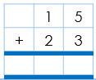

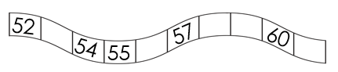

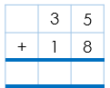

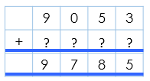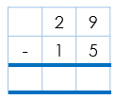

**Quick Comprehension:** Complete the reading comprehension. Children should allow themselves one minute to read the text, and five/ten minutes to answer the questions. Some of the questions are quite tricky, so don’t worry if you have to talk them through with an adult.

**Spellings**

|  |  |
| --- | --- |
| **Core**  salary  stationary  necessary  anniversary  historic  traffic  picnic  tunic  long  along  last  fast  best  next  believe  reign | **Support**  demist  debug  decamp  decode  deform  defuse  road  toad  load  coat  goat  throat  look  too  regular  particular |

|  |
| --- |
|  |

**SPaG Challenge in books please**



**Times Tables Activities**

**Please do some of the following:**

Daily times tables on TT Rockstars

Daily time tables in booklet

Times tables training grid

Times tables wheels

Daily chanting and oral questioning

Please remember: All homework is marked in class with the children and will not have written feedback on it.

Homework is due in on the following Friday.

